Author | Date last updated | Title of Webpage | Date accessed | HTTP
Author | Date of Publication | Title of Book | Publisher |  | Place of Publication

Bibliography

Write out your references in full to create a formal bibliography. References should be written in alphabetical order according to the author. An example reference would look like this:

Book

S. Mirams. (2015). The USA 1900-1945. Melbourne, V.I.C: Cengage Learning

Webpage

The White House. (n.d.). Presidents. Retrieved from https://www.whitehouse.gov/about-the-white-house/presidents/

Bibliography

UWA APA Referencing Guide – Examples

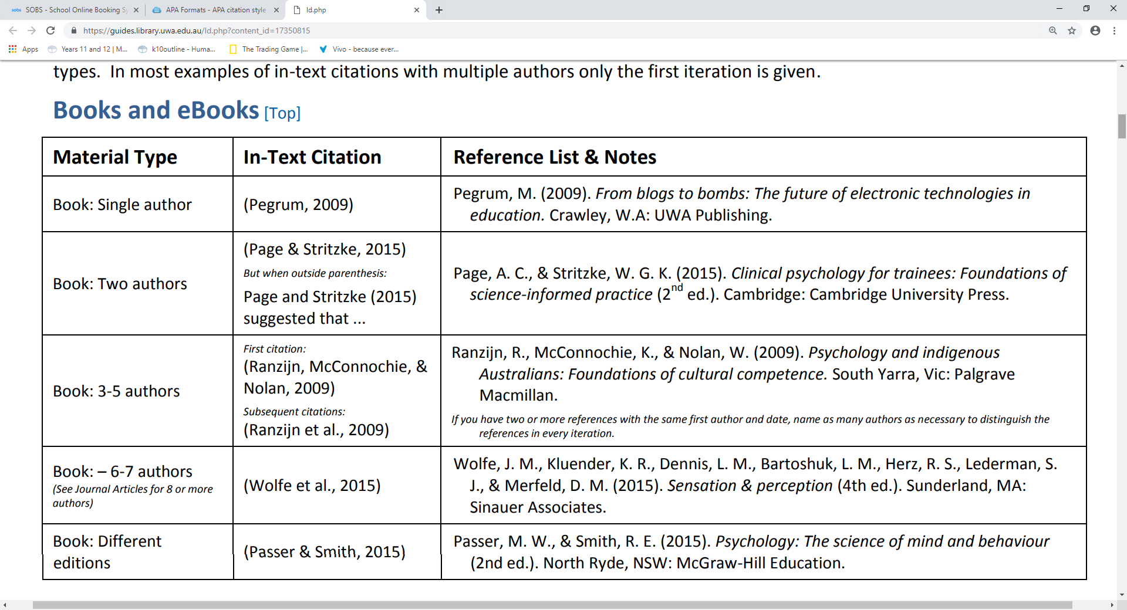
https://guides.library.uwa.edu.au/ld.php?content_id=17350815

